Point of Progress Engagement and Behaviour

________________________________________ October ________________

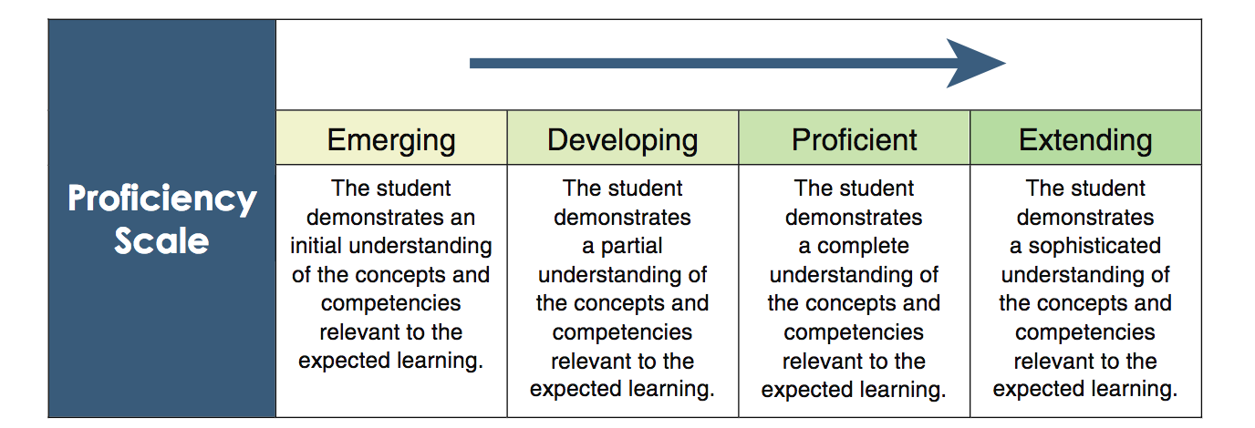

Student Engagement and Behaviour: EM D P EX
Is respectful to adults and other students
Shows respect for the work and property of others
Keeps personal belongings neat and organized
Follows rules and routines in the classroom and on the playground
Listens attentively
Follows directions
Is able to stay on task using time effectively
Makes an effort to complete work neatly and carefully
Generally completes work on time

Teacher Comment: ________________________________________________________

_________________________________________________________________________

_________________________________________________________________________

_________________________________________________________________________

________________________________________________________________________

_________________________________________________________________________

_________________________________________________________________________

(Student picture or drawing showing learning)

____Student description of above_________________________________________________

____________________________________________________________________________

____________________________________________________________________________

Reading is… a little tricky okay fantastic

I can do math… but it’s hard work slowly but surely wonderfully

Writing is… hard all right fabulous

I listen and follow directions… not usually sometimes all of the time

I read 30 minutes at home … once in a while almost every night every time

I do my best work… not usually sometimes all of the time

My work is complete… not usually sometimes all of the time

