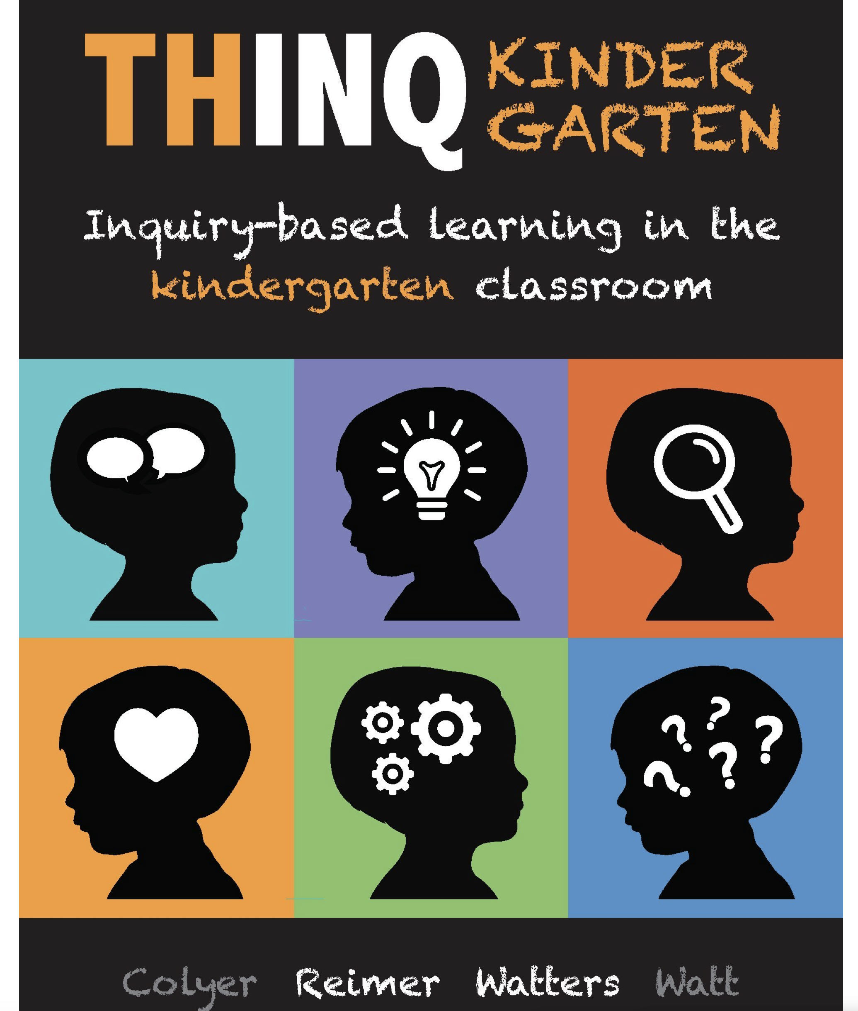
THINQ Kindergarten
Inquiry-based learning in the kindergarten classroom
Reviewed by: Kristin Holland, Jane Beswick, Kelly Hancock, Kareen Kimoto, Elisha Anderson (Happy Valley)
This is an excellent book for any early primary teacher who is new to inquiry or who wants to improve in their practice of teaching through inquiry. THINQ Kindergarten is one in a series of Inquiry books: THINQ 1-3, THINQ 4-6, and THINQ 7-9. These books are from Ontario and blend well with BC’s new curriculum. We appreciated the focus on Kindergarten, as many inquiry books do not include examples that are applicable to early childhood.
The book is organized by these topics:
Chapter 1 –It’s all about the wonder: Inquiry-based learning in Kindergarten
Chapter 2-Wondering and questioning: The key to inquiry learning
Chapter 3 –Creating an inquiry environment: The context for learning
Chapter 4 –Negotiating the curriculum: Co-creating learning
Chapter 5 -Documentation: Making the learning visible
Chapter 6 -Inquiry assessment in kindergarten: Improving and sharing learning
Chapter 7- The heart of inquiry in kindergarten: What matters most
This book is easy to read, includes many photos and examples, and organizes information through the use of many visuals. Visual organizers were a bit similar to one another, which was our main criticism.
Overall, we recommend this book to any K-1 teacher who wants a great resource to begin or enrich the inquiry learning in their classroom.

