Core Competency Self-Assessment

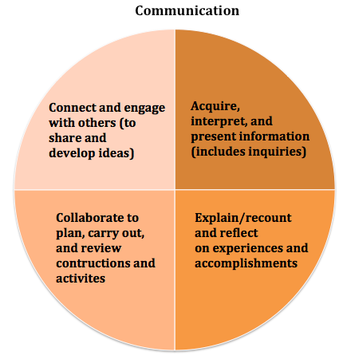

Core Competency | “I...” | My demonstration or artifact and reflection.
Communication

- When safe and supported I can engage with friends and adults.
- When supported I can work with others.
- When comfortable, I can communicate, share information, and plan activities with others; I can also talk and listen to people I know.
- I can participate in friendly conversations when helping, or sharing basic information. I can work with others and do my share of the work. I can share out on what I did and learned.
- I am gaining confidence with peers and adults. I can listen, ask questions, and encourage others to do the same.
- I can gather basic information on topics of interest to me and can present it to others.
- I can communicate clearly and can share my ideas. I actively listen and ask clarifying questions. I can plan and work with others to develop plans while giving and receiving constructive feedback.
- I can gather information easily from a variety of reliable sources. I know my audience and have a clear purpose when I present.
- I can contribute positively to discussions and work well in collaborative environments with my peers.
- I am a good communicator, I am clear and well thought out when speaking to different audiences. I also listen to others ideas and see similarities in topics.
- I can draw on a variety of strategies and experiences when leading and supporting groups.
- I can acquire, analyze and create well-written pieces of work from a variety of texts.
- I can be a leader and am supportive of others.
- I am a flexible thinker, and am able to reflect and move forward with new goals.
- I can communicate through technologies well.
- I can be a leader when collaborating and help take thinking and learning deeper.
- I know who I am and can communicate this clearly. I am clear with my goals and progress in work and learning.

_______________________________________________________________________________

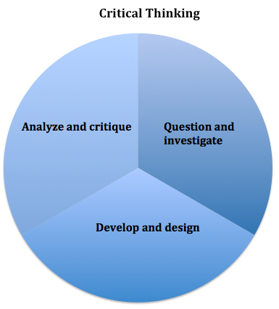

Core Competency | “I...” | My demonstration or artifact and reflection.
Critical Thinking

- I can explore. I can explore materials and actions.
- I can show if I like something or not.
- I can use evidence to make simple judgements.
- I can explore learning, ask questions, make predictions and use what I learn. I can talk about or show something about my thinking.
- I can come to conclusions and make decisions based on experiences, things I saw, and what I think might happen.
- I can ask open-ended questions, gather information and experiment to try and develop options for problems or curiosities.
- I can describe my thinking and how it is changing.
- I can gather evidence to gain knowledge to answer problems, make plans or make a decision.
- I can use what I know and observe to identify problems and ask questions.
- I can think about and consider more than one way to make decisions.
- I can develop criteria, assess my thinking, and come to conclusions, judgements or plans.
- I am flexible and open-minded. I can examine my thinking, get feedback, reflect on my work and make new plans.
- I can gather and evaluate resources at a high level (identify alternatives, perspectives, implications) and ask further questions and draw conclusions.
- I can examine evidence from a variety of perspectives and make decisions on complex issues.
- I can consider alternative approaches and make strategic choices.
- I can develop my own criteria and plans for tasks that involve critical thinking.
- I can consider views that do not match my beliefs; I am patient, open-minded, and understanding.
- I can take the results of my inquiries and make further action plans.

_______________________________________________________________________________

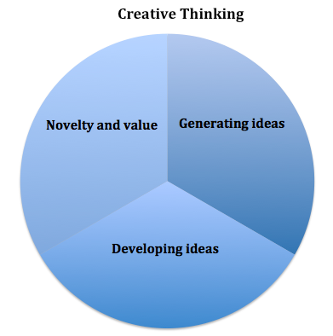
Core Competency | “I...” | My demonstration or artifact and reflection.
Creative Thinking

- I get ideas when I play. These ideas are fun for me and make me happy.
- I can change my ideas if things are not working for me.
- I can use other people’s ideas to get new ideas for myself when creating something, solving a problem, or making something.
- I can create new things or solve problems using my own ideas, others ideas or building on others ideas.
- My ideas are fun and useful for me and my friends, especially when we are trying to solve problems or build something. Overall, I feel good about my ideas.
- I can build new ideas and make things work or solve problems when I am interested.
- I can and like to learn about new things so that I can come up with new ideas.
- I can learn new skills to make my new ideas work even if it takes me a few tries.
- I can come up with ideas that help my peers.
- My creative ideas are usually a form of self-expression for me.
- I can take a brain-break when I need so that I am more creative when I get back to my work.
- I can continually build on creative pieces when it’s in an area of interest to me.
- I can make a difference in my community or beyond using my creativity.
- I pursue my interests and passions.
- I am willing to take risks in my thinking and am okay with uncertainty, failure and setbacks as they help advance my thinking.
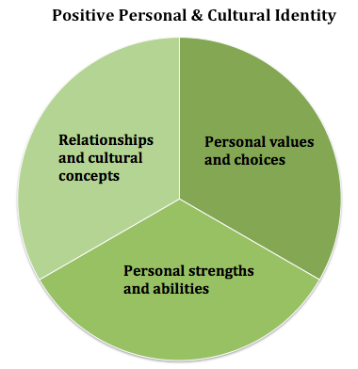

Core Competency | “I...” | My demonstration or artifact and reflection.
Positive Personal and Cultural Identity

- I am aware of myself and am different from others.
- I know my name and with support I can talk about who I am and what makes me different from others.
- I am aware of the different aspects of myself and can identify some of my features and qualities.
- I can identify people, places and things that are important to me including my family, home and community.
- I can explain what I like, dislike and what interests me.
- I have pride in who I am and can talk proudly of myself and my abilities.
- Through words and/or images, I can talk about my family, communities, school, and peer groups and how I contribute to them.
- I understand that who I am (my identity) and what I do is influenced by the people and groups around me.
- I understand that experiences, family history, heritage, where I live, and groups that I feel connected to (family, friends, online communities) help to make up who I am and the choices that I make.
- I understand that who I am / who I have become is a unique person and I am important to my communities (family, social, etc.)
- I know that my identity will continue to develop over time and is always changing.
- I can describe why I value and choose certain things over others.
- I understand that challenges are opportunities for personal growth and that I will continue to grow over my lifetime.
- I can identify my potential as a leader within communities that I am a part of.

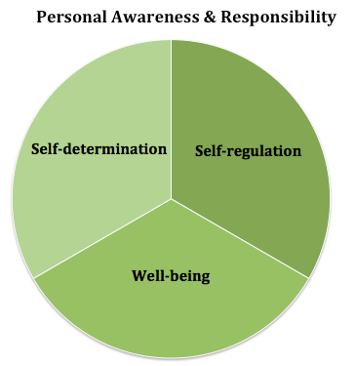
Core Competency | “I...” | My demonstration or artifact and reflection.
Personal Awareness and Responsibility

- With support, others can see that I am proud and happy with myself. I sometimes recognize my emotions.
- I can let people know what I want, need and choose over other things.
- I can manage my feelings and emotions.
- When feeling safe and with support, I can share and be responsible for what I have done.
- I understand that my actions have consequences and I can manage my feelings and emotions.
- I can express my wants and needs and celebrate when I try something or accomplish something.
- I can manage my stress and complete goals.
- I can create realistic goals and try hard to complete them. I persevere when tasks are challenging for me.
- I can recognize and control myself when upset.
- I know how to be safe in a variety of communities, including online.
- I accept myself and advocate for myself when I need to. I take responsibility for my actions.
- I can take responsibility for my learning: set priorities, plan, adjust plans and reflect on the results, seeking help when I need it.
- I work on having a balanced lifestyle and keeping myself happy and calm.
- I know how to find social support if I need or want it.
- I know my strengths and where I could grow and develop. I make ethical decisions when I can.
- I set goals for myself and work on them when I can.
- I make decisions and talk with others if they don’t like them, or if they were affected by them.
- I am aware of my personal journey and take time to reflect and grow regularly.
- I can advocate for myself in stressful situations.
- I take time to learn about controversial issues and try to understand the more ethical side.

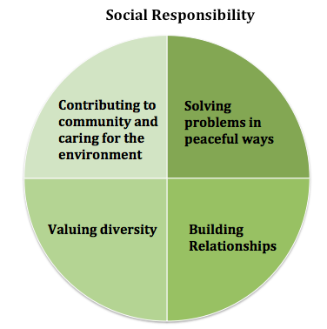
Core Competency | “I...” | My demonstration or artifact and reflection.
Social Responsibility

- I am aware that people are different than me.
- I can play with friends and with support, I can be part of a group.
- When comfortable and with structure, I can be with others and be a good, kind person.
- I can share my feelings and listen to others’ views.
- I can solve problems myself and I can ask for help if I need it.
- I know when others need help and with some help, I can be inclusive to support them.
- I can interact with others well and can make good friends with whom I choose.
- I contribute to groups and help make my communities a better place to be.
- I consider other people’s opinions and can express my opinion in a nice way.
- I can identify problems and can come up with strategies to solve them.
- I can be inclusive and respectful and know when something is unfair.
- I recognize when others need support and can provide it, including elders.
- I understand that my actions and the actions of others can make a positive difference.
- I can clarify problems or issues, I can consider alternatives and consider strategies.
- I understand that we are all different and I demonstrate an inclusive behaviour.
- I can advocate for others.
- I can establish and keep relationships with younger and older people.
- I can create positive changes for people and the environment.
- I can analyze complex social and / or environmental issues and can take action to help make positive changes.
- I am good at clarifying issues or problems, coming up with strategies, consider consequences and am flexible with coming up with solutions that work for most.
- I support and defend human rights and recognize that differences are good for my communities.
- I can build and sustain good relationships with people from a variety of age groups, communities and cultures.
- I can empathize with others and can adjust my behaviour to accommodate their needs.

